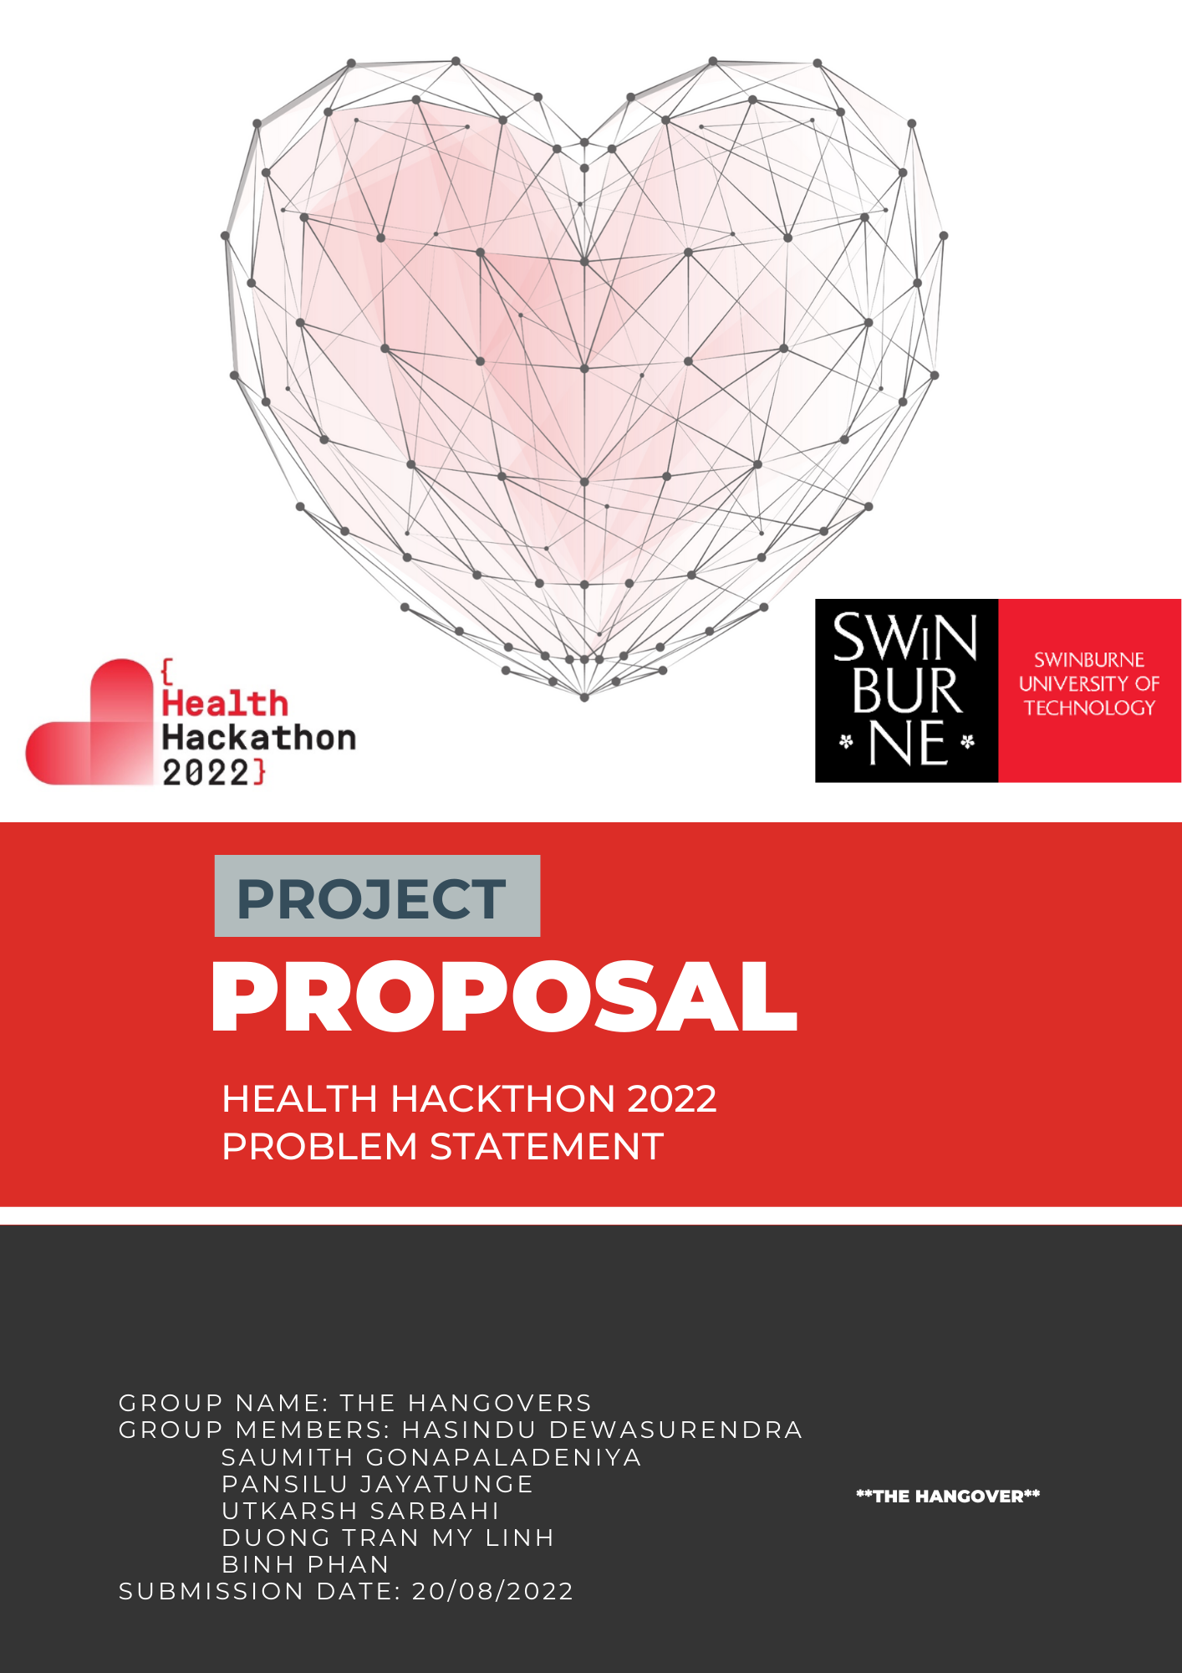

**

# **I. Background**

Sign Languages have emerged as viable methods of communication wherever groups of people with hearing impairment exist, and they are very much at the heart of such local cultures. Although signing is primarily used by the hard of hearing, it is also utilised by hearing people who are unable to speak or have speech impairments, have difficulty with spoken language due to a disability or condition (especially augmentative and alternative communication), or have family members with diminished hearing capabilities, such as children of such adults.

# **II. Our Concept**

Our team proposes the creation of a Python-based Digital Sign Language Interpreter Application. We use OpenCV and MediaPipe libraries and deploy our application as a stand-alone Web Application, making it cross-platform. Using our developed Machine Learning or Trained Neural Network model as the core, it will be able to capture and detect, recognize and analyse a series of live hand gestures on a real-time basis, essentially through Computer Vision, therefore greatly automating the process of a Sign Language conversion to English and other widely spoken languages in the form of texts and speeches via Natural Language Processing, boosting the efficiency and engagement of the process of teaching and communicating in sign language among persons with special needs. Also, besides live video feed, we can also input a pre-recorded version and get the translated text or speech as the desired output for people to comprehend sign language with minimal effort.

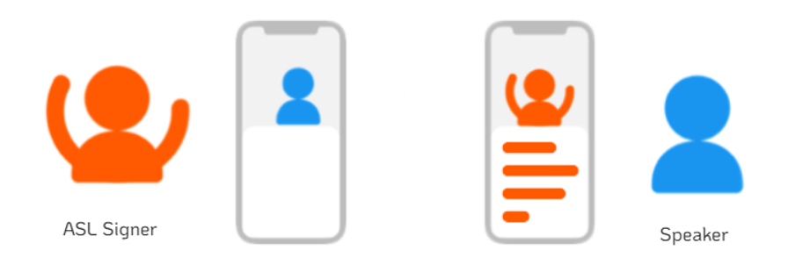

Figure 1: Seamless interaction between an American Sign Language user and an ordinary person

The following software flowchart captures the operation outline of our system,

Figure 2: TransL application software flowchart

Our program intends to make sign-language communication more convenient on an individual level, like how popular translation tools like Google Translate and Microsoft Translator work. The most fascinating aspect of this solution is that anyone with a hearing or speech impairment can use it to express themselves anywhere, at any time, without having to consult or hire a trained professional, promoting and facilitating equal employment opportunities in a variety of work environments. And one of the most ambitious expansions that we can see happening out of this emerging technology involving Artificial Intelligence, is its integration into modern-day video communication software applications to facilitate day-to-day conversations, way more conveniently than ever before.

# **III. Probable Risks and Challenges**

There are hardly any risks during the usage of this application since the entire solution barely employs anything else. An ordinary computer and a webcam, or even just a simple laptop or phone with a camera and decent processing power would suffice. However, the most challenging aspect lies in expanding the dataset so that the Recurrent Neural Network and the Artificial Intelligence Models can be improved and refined further for enhanced accuracy and precision for real-time Sign Language translation, before attempting incorporations with other significant consumer applications. Furthermore, the crucial component for any robust Machine Learning model is surely a reliable database, in our case video data for interpretation of the Sign Language in use, and there simply isn’t a lot of that available.

A caveat that needs to be stated here is that this is a kind of solution that shall always be devoid of absolute completion, just as translation and transcription in or to any language is only an approximation. The major point is to provide practical results for millions of people, and therefore even just hundreds or thousands of words go a long way towards doing so. As abundant data pours in via communities who wouldn’t mind their use of the system being turned to its improvement, new words can be added to the vocabulary to create a comprehensive library, and other multi-gesture phrases as well, thereby eventually improving the performance for the core set.

# **IV. Overall Inclusivity**

Sign Language is used by millions of people around the world, but there has not been any automatic translation available. People with hearing impairments, or other conditions that make vocal speech difficult, or even the ones who do not possess any particular sensory or cognitive disability but simply just want to understand it, as mentioned earlier amount in the hundreds of millions, rely on the same common tools as the hearing population. But while emails and text chats are useful and of course very common now, they aren’t a replacement for face-to-face communications, and unfortunately there’s no easy way for signing to be turned into written or spoken words, so this remains a significant barrier which we are basically trying to resolve.

With the number of conversations, especially digital one’s going on these days and likely to exponentially increase for the rest of eternity, accessibility is being left behind as only some platforms offer automatic captioning, transcription, summaries, and certainly none recognize Sign Language. But with our conceptualised idea, people with different disabilities could sign normally and participate naturally rather than using the neglected chat function, via simple hand and arm gestures to bridge the acute gap in making effective communication

# **V. Potential Impacts**

* **Health Care:** Direct interactions with any doctor can be conveniently engaged in for quick diagnosis by vulnerable people and can also be extended to a doctor – Patient Appointment system.
* **Daily Communications*:*** Communications can be performed effortlessly with loved ones or even with other strangers, using Sign Language and live transcription.
* **Career Development*:*** More opportunities can be generated by having a pleasant environment for people with speech and hearing impairment.
* **Education and News*:*** Online classes, media presentations and other virtual sessions can be made more accessible for both persons with cognitive and sensory disability, as well as for an abled person who’s trying to comprehend Sign Language.
* **Video Communication and Online Translation companies*:*** With our automated Sign Language transcription technology, these services can be made available for customers with disabilities as well on platforms (e.g.: *Zoom Video, Google Meet, Microsoft Teams*)
* **VRI (Video Remote Interpreting) and VRS (Video Relay Service):** Again, with our computerised Sign Language transcription technology, not only staff costs can be reduced but also a specially trained ASL interpreter wouldn’t be required anymore.

# **VI. Business Aspect**

**1) Value creation**

In the age of unprecedented pandemic outbreaks, it is more essential than ever before to help the people with disabilities feel supported and safe. Nevertheless, our project has one sole goal: to make this world a more connected & inclusive place, where no one is left out. By providing the disabled community with our powerful live machine-learning translator model, achieving effective communication between different communities, different disabilities as well as spreading new information, knowledge and ideas should be simple, effortless and free of charge. This prototype aims to be a more efficient platform, allowing its users to be more independent while not having to always rely on personal relationships.

**2) Target & Industry**

According to the WHO, the estimated number of people having speech/hearing impairments is around 246 million. They represent a hugely underserved market for brands wishing to reach new customers and build unique new experiences and content. Companies want to make their customer service offerings more accessible. For them, we’ve built a simple but beautiful tool.

As a part of the community, most people schedule their daily lives to spend money and time in connecting with the local resources. Facts and sources suggest a base of 2 million American sign language speakers in America only and approximately 500 million people worldwide with hearing or speech impairment. Addressing this community with our free to use web application ‘TransL’ provides us with a well-established breakthrough that translates sign language into English text and speech. With a completely unique design and product at our hands that many translating apps (even *google translate*) or hospitals in the healthcare sector; no integrated the use of translator apps for mute and deaf patients, we believe the market for this design to be huge. Potential consumers include global brands like *Walmart, CVS Health* and other major grocery restaurant chains that account for a huge portion of our target crowd. Further, we will welcome partnerships that support to implement this prototype into a few selected hospitals to cater the patients with disabilities and help the speech and hearing-impaired community to guide in their tasks without encountering the frustrating accessibility barriers.

A lot of people don't know this, but one of the reasons *Zoom* is so successful is because it was designed with accessibility in mind. Part of it is that you can't get government contracts and be accepted in education unless you meet certain basic requirements. But it's also about usability and making sure you're giving the average user a good experience. Accessibility goes way beyond disability. So, we need all our companies, all our websites to make sure they're accessible to everyone right now, or else somewhere in the realm of a billion people will truly become isolated.

**3) Marketing**

There are so many things that impaired individuals could use support with – so many amazing experiences that could be provided once digital products and all languages are adequately accessible. But it's also about usability and making sure you're giving the average user a good experience. Accessibility goes way beyond disability. So, we need all our companies, all our websites to make sure they're accessible to everyone right now, or else somewhere in the realm of a billion people will truly become isolated.

When a brand partners with us, we provide them with a profile in the app that allows mute/deaf users to get information, links to services, and a real time video processing translator in your particular system. As a brand you can decide what service you want to provide: whether it's tech support, experiential marketing, or just basic information and referral services. We are giving any organisation who wants to interact on a human-to-human level a chance to field calls just like our volunteers. The experience is just as rewarding as volunteering – and gives your company incredible new insight into your product’s accessibility and usability, from an inclusive design perspective. As brands look to move beyond advertising and find meaningful ways to help engage and help their customers, our project should be a first stop for marketers who are passionate about finding innovative ways to do good.

**4) Product Value delivery**

Greater numbers of people can keep track of the events shaping our world, understand their impact on people and communities, and become inspired to take meaningful action. Millions can benefit from open access to quality, truthful news, regardless of their ability to pay for it.

**5) Funding**

Keeping the true ethical focus in mind, which is to empower the disabled community and link people together regardless of the limits/language barriers, we provide and implement this application all free of charge, for the impaired individuals. communication between humans in this world should be freely facilitated no matter what backgrounds. We will work with Specialised Help providers – *Microsoft, Google, P&G* and others, design full partnerships, some of which include a mixing and matching of corporate volunteering programs so that staff can chip in to volunteer virtually, internal solutions to help them support their mute or deaf employees, and tons of resources toward fun and fascinating campaigns that really make people stop and think about why and how to make our world more accessible for everyone

# **VII. Conclusion**

'What matters most are a person's skills, not their infirmities.' With that initiative and motive in mind, we hope to create something eloquent for people with sensory and cognitive disabilities using all of our existing engineering expertise, which will not only give them a ray of hope that they, too, belong in the workplace, but also provide them with enough freedom and self-confidence to thrive in their lives in the most fulfilling way possible.